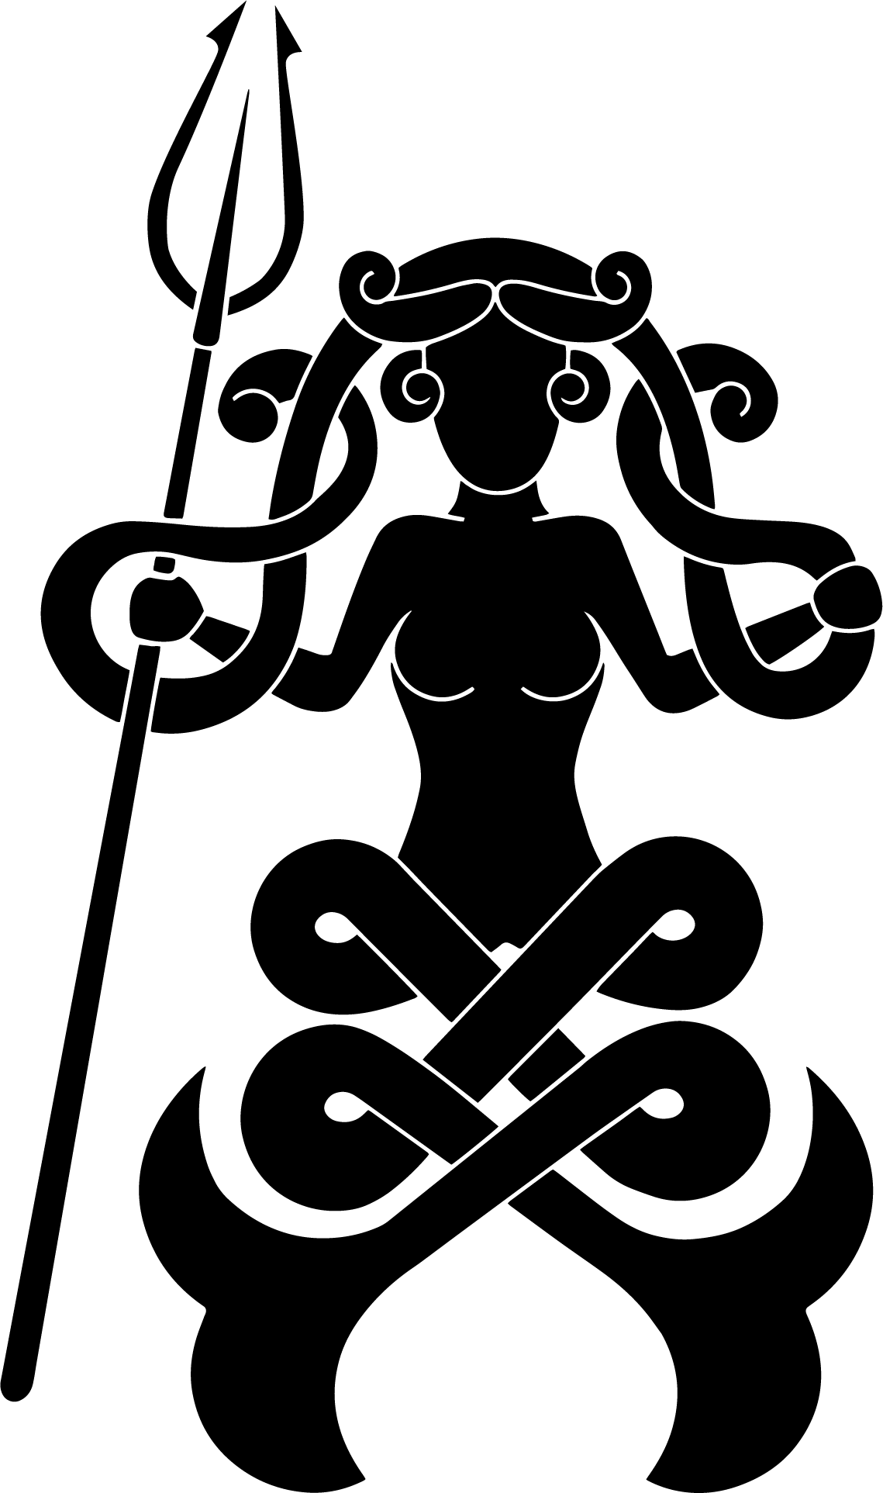
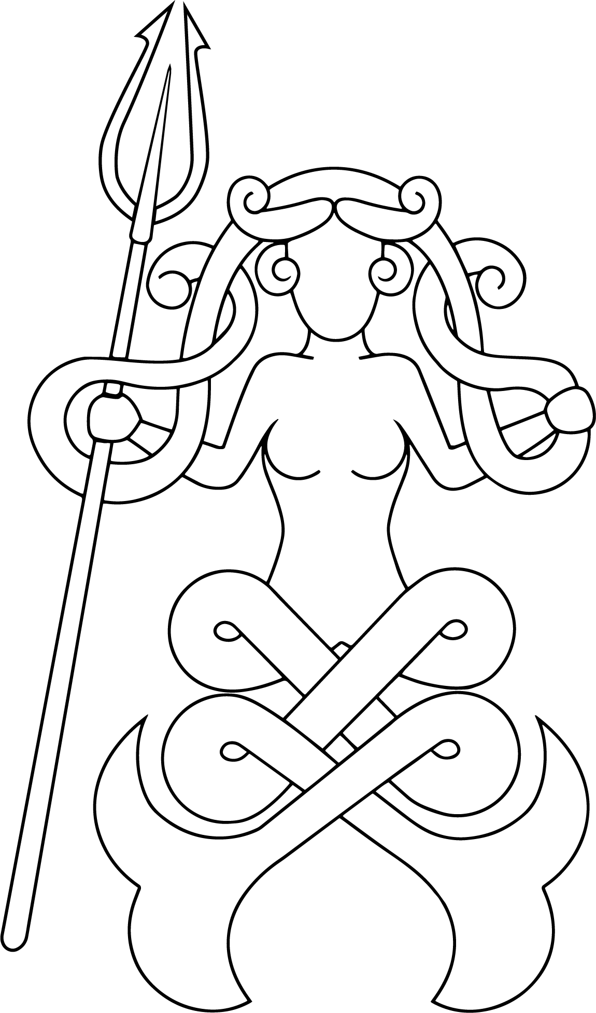
Caoilfhionn’s Favor

The design is based on a previous favor design by Violet Gray, based on a pictish carving is a mermaid modified from a pictish carving now known as the “Meigle Mermaid”. To represent Caoilfhionn’s 3rd reign, a trident was added by Anastasia da Monte. Culann mac Cianain and Caoilfhionn together created this version, adding 2 loops to the mermaid’s tails to signify reign four.

Her Majesty encourages creativity in the creation of Her favors, and wishes for all to have fun with this project.

Design: A two-tailed mermaid a melusine), her tails are looped in knotwork style to create four loops. In her right hand is a trident.
Elements:
- Background: Bright royal blue, similar to DMC 824
- Artwork: The design can be done in any of the following manners, at the discretion of the artist
  - As an outline
  - As a filled design
  - White mermaid with Gold (DMC 3852 or metallic) trident
  - “Natural” colors akin to green (DMC 702) tail, brown (DMC 300) hair, beige-pink (DMC 543) skin, with gold (DMC 3852 or metallic) trident
Techniques: Embroidery (hand or machine), paint, applique, silkscreen, fabric stamping, metalwork, beadwork, leatherwork, or other techniques. Creativity is encouraged! Have fun!
Dimensions: Finished favor should be approximately 4” wide by 8” long including belt loop.
Construction:
- Each favor can be constructed as a single layer of fabric or as a more sturdy fully-backed piece.
  - Single layer: cut fabric to 5” by 12” and do a narrow rolled hem on all 4 sides
  - Fully-backed favors:
    - two 5” by 12” pieces stitched together, turned right-side out and the opening stitched shut
    - one 10” by 12” piece, stitched down the long side into a tube, flattened, stitched across the bottom, turned right-side out, and the opening stitched shut
  - Before adding the belt loop, the pieces should be approximately 4” wide by 11” long with finished edges
  - Fold over about 3” and stitch down to make a belt loop
Delivery:
- Mail to Martha bean ui Bhradaigh:
Martha Brunelle
14 Kingston Avenue
Port Jervis, NY 12771
- In-person delivery to Martha, handed to any of Caoilfhionn’s retainers, or dropped off at the Royal Room.
Please include a note with your SCA name, your modern name and mailing address with any favors you give.
Her Majesty greatly appreciates your help in creating Her favors – Thank You!

